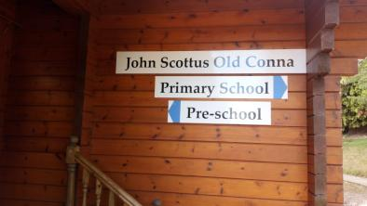
23rd September 2019

Our first Newsletter!!!!!

I had hoped it would be very snazzy and professional but until my IT skills move up another league I am going to content myself with words and pictures!!!

So many firsts in the last number of weeks.

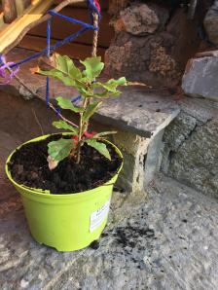
One of the first ‘labours’ in our treasured surroundings was the planting of an Oak Sapling by our Pre-Schoolers. On every level this event speaks volumes- it is small, fragile and dependent but with care, nourishment and attention who knows what will happen! It may reach its potential as a mighty Oak, giving shelter, fun and sustenance to everything around it. I think this is not a bad analogy for our new enterprise and symbolic of what is happening in Old Conna. Thank you Vanessa and Ilana for providing us with this great opportunity.

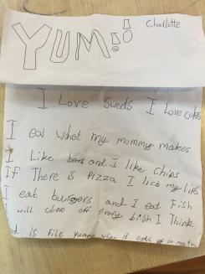
Our first poem: It came literally out of the moment. Ms Dempsey was finishing her Friday assembly and asked if anyone wanted to offer anything to the rest of the boys and girls. Without a second’s hesitation Charlotte was on her feet reading her poem in her beautiful presentation voice. It got sincere applause and its particular rhyming effects were praised. I was gobsmacked and had just enough presence of mind to request that it go into the news letter.
Our poet-in-residence smiled, gave it to me to photograph and then ran off!!

Hopefully these little vignettes give some flavour of our recent days.

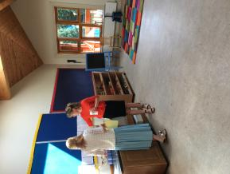
As discussed at our evening meeting with the Pre-School parents, key purposes of the Newsletter will be to keep you informed of what is happening, letting you know dates, events, updates on teachers and passing on any general information that keeps us all in touch and connected.

Dates for coming weeks:
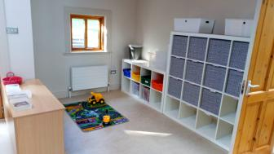
Thursday 26th and Friday 27th September: Senior School not in operation.
Catering will be as normal except that on Friday we will be having sandwiches.

Wednesday 2nd October: Open Assembly in play area, followed by Ms Lai meeting with pre-school parents.

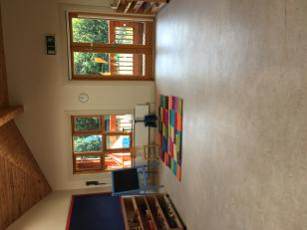
Friday 4th October Ethos day: Ms Dempsey and Ms Lai with Pre-Schoolers and Ms Orla with Primary.

Health and Safety.
Thank you for all your cooperation on this front to date. As the campus comprises three schools, it is important to be able to account for all persons who come on campus. We will be giving parents of both Pre-School and Primary a ‘safe word’ for identification purposes. Should a member of staff of any of the schools question your presence or someone designated by you to collect your child, your identity can be verified by letting them know the ‘safe word’.

Any parents interested in making enquiries regarding the Secondary School can visit reception in the main school building and make an appointment with the Secretary.

I hope to get a Newsletter out on a regular basis. No doubt it will evolve in its functions and format as we progress through the year but I hope this first effort indicates its potential.

Mary Telford
Chariperson,
Board of Management OCPPS.

