Friends Together

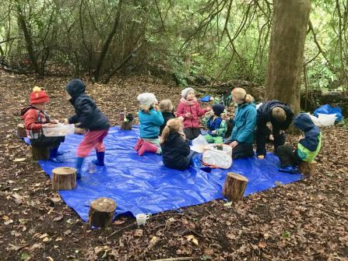
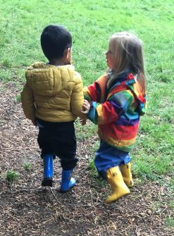
The Forest schooling has started!
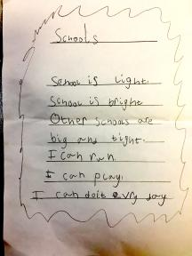
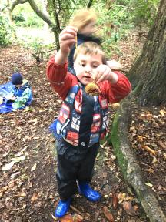
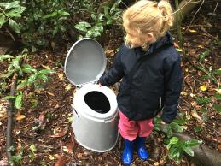
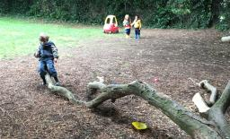
Friday last was amazing and a joy. The Primary had their first real foray into the forest and they loved every minute. They ate, they played, they made bird feeders, they climbed and swung on ropes. They could even answer the call of nature in a private secluded spot with no interruptions.
NEWSLETTER 2.
Primary & Pre-School John Scottus Old Conna

DATES for DIARY

Mon 14 Oct
Return Pobal forms.

Wed 16 Oct
Primary Open Assembly

Th 24 Oct
Ms. Lai on In-Service Day
Ms Dempsey takes the Pre-School
Ms. Orla - Primary (Forest School)
Fri 25 Oct
Half Term
Hallowe’en Celebrations
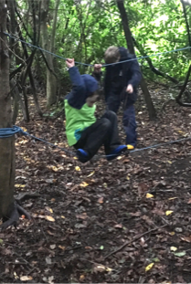
1
2
3
It showed what can happen when the will and organisation is there. These trips to our on site forest can be a regular feature of a JSS education. They are nurturing and profoundly educational.
Our Pre-Schoolers are not to be left behind either. They test themselves, explore and grow.
Poetry continues and comes unbidden!

